

Session 2022-2023

# Free Vector | Grey technology background

# Training Programs and Cerfications

*with Specialization in* ***Integrated Circuits***

**“A training from Idea to Product Design”**



***Unique IC Design Training Programs with specialization in Digital, Analog, RF and IC Verification***

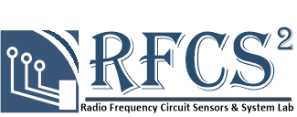

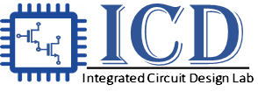

**Salient Features and Objectives of Programs:**

## *Pioneer of Integrated Circuits (IC) design graduate programs in Pakistan.*

* *First time in Pakistan an academic opportunity for IC designing on* ***Licensed Cadence Tool Suite.***

### ***Well Established collaboration*** *with public and private industrial partners.*

* *Hands on design experience on* ***TSMC officially provided 65nm, 130nm and 150nm*** *CMOS PDKs.*
* ***Fully developed ICD lab and curriculum*** *with six full time faculty members with degrees in IC design and cumulative experience of* ***over a dozen IC tapeouts****.*
* ***A bridge between the industry‐and‐academia*** *to pave the way to FAB‐less innovations resulting in commercialization IC design houses.*
* ***25 fully industrial funded MS students*** *graduated in Fall-2021, hired by public sector organization.*
* *Taped out 8 Projects on two IC’s by MS students graduated in Fall-2021.*
* ***18 students*** *enrolled in Fall-2021 (50% hired by industrial partners during second semester).*

# MS EE (Specialization in IC Design) Objectives:

This program is tailored to train human resource for globally 500 Billion US$ semiconductor industry. The goal is to equip youth with comprehensive integrated circuit (IC) design and verification expertise including, theoretical in-depth knowledge, hands-on IC design tools skills, and end-to-end IC design and verification training. Each student in this program will design the real world IC’s from project conception to the working silicon microchip under the guidance of faculty supervisor from university and industry experts.

#### Eligibility:

Bachelor’s degree in a relevant engineering discipline (Electrical, Electronics, Telecommunications, or Computer engineering, etc.), recognized by Pakistan Engineering Council (PEC). Minimum CGPA of 2.0, Preferably 2.5 (on a scale of 4.0) or at least 60% marks.

#### Tentative Degree Road map:

|  |  |  |
| --- | --- | --- |
| Semester‐III | | |
| EE | Elective-IV | 3 |
| EE | MS Thesis‐I/Project-I | 3 |
|  | Total | 6 credits |

|  |  |  |
| --- | --- | --- |
| Semester-I | | |
| SS | Research Methodology | 3 |
| EE | Core Course‐I | 3 |
| EE | Core Course‐II | 3 |
| EE | Elective-I | 3 |
|  | Total | 12 credits |

|  |  |  |
| --- | --- | --- |
| Semester-II | | |
| EE | Core Course‐III | 3 |
| EE | Elective-II | 3 |
| EE | Elective-III | 3 |
|  | Total | 9 credits |

|  |  |  |
| --- | --- | --- |
| Semester‐IV | | |
| EE | MS Thesis‐II/Project-I | 3 |
|  | Total | 3 credits |

**Total of 30 credits for MS program**

#### Tentative Course Plan:

**Integrated Circuits Master’s Program**

**SEMESTER-1 SEMESTER-2 SEMESTER-3 SEMESTER-4**

**Fall-2022 Spring-2023 Summer-2023 Fall-2023**



1. Master Thesis /Project(Part-I)



1. Master Thesis /Project(Part-I)
2. **Elective-IV**



1. Mixed Signal

Integrated Circuits

1. **Elective-II**
2. **Elective-III**
3. Research

Methodology

1. Digital Integrated Circuits
2. Analog & DT ICS
3. **Elective-I**

**Note: Electives are selected depending on the type of specialization i.e Analog, Digital or RF**

The **total credits of the MS programs are 30**, which includes the **24 credits** of the course work including the 03 credit Research Methodology Course and 06 credits of the MS thesis work industrial Project.

Note: Registration in “Project – I or Thesis-I” is allowed provided the student has:

* + Earned at least 15 credits
  + Passed the “Research Methodology” course;
  + CGPA is equal to or more than 2.5

**MS (Electrical Engineering – Specialization in Integrated Circuits):**

**Core Courses for MS‐EE with Specialization in Integrated Circuits:**

* 1. Research Methodology ( 03 Credits) (HEC Requirement)
  2. Digital Integrated Circuits ( 03 Credits)
  3. Analog & DT Integrated Circuits ( 03 Credits)
  4. Mixed Signal Integrated Circuits ( 03 Credits)

**Elective Courses (One must select minimum of 3 courses from this list of Electives)**

1. Signal Integrity, Packaging and SoC Design ( 03 credits)
2. IC Design Project: From Schematic to Chip Tapeout ( 03 credits)
3. RTL Synthesis,& Digital Backend ( 03 Credits)
4. RF Integrated Circuits ( 03 Credits)
5. Nano Electronics ( 03 Credits)
6. Printed and Flexible Electronics ( 03 Credits)
7. Advance Microwave Engineering ( 03 Credits)
8. Advance Embedded Systems ( 03 Credits)
9. Advance Digital Signal Processing ( 03 Credits)
10. Advanced Wireless Communication ( 03 Credits)
11. IC Marketing and Business Management ( 03 Credits)

# Graduate Diploma Program Objectives:

The graduate diploma program is especially crafted for industrial/academic organizations to develop skilled IC design in a short period. This program is fully dedicated and focused on the IC design knowledge and skills. Each student in this program will be taught comprehensive IC design curriculum, and a comprehensive IC design cycle, with hands on experience in IC design and testing tools/equipment in one year. The program will help to develop the IC design echo system in Pakistan by training human resource which is a critical bottleneck in establishing IC design business in Pakistan.

#### Eligibility:

Graduation in EE/TE/Mechatronics/CS or equivalent.

#### Admission:

**The diploma program will be offered on demand.**

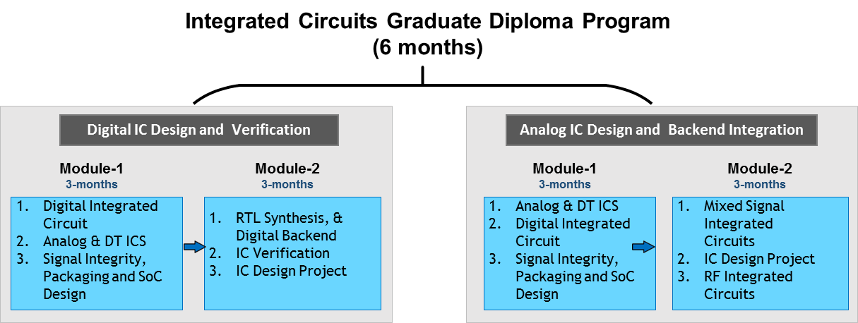

**Graduate Diploma in Integrated Circuits Design:**

Courses for Graduate Diploma in Integrated Circuits:

1. Digital Integrated Circuits
2. Analog & DT Integrated Circuits
3. Mixed Signal Integrated Circuits
4. Signal Integrity, Packaging and SoC Design
5. RTL Design Synthesis
6. IC Design Project: From Schematic to Chip Tapeout
7. RF Integrated Circuits

# Integrated Circuit Certification Objectives:

The program is also offering short 3 months certifications specializing in IC Verification, Digital, and Analog IC along with the High-Speed PCB design The PCB design was thought to be a technician job in recent past. With the advancement in technology, the issues thought to be IC designer concerns like cross talk, reflections and impedance control are major cause for PCB failure if not addressed properly before starting the layout. High-speed circuitry is used in all modern products. Understanding high-speed fundamentals and the relationship of speed to distance and how to apply this knowledge is the key to successful design. These certifications are focused on the short hands-on courses which cover the basics and hands-on IC design skill for each individual. Especially the verification course is tailored in such a way that it in line with the industrial skill demands for the verification companies that have been recently started in Pakistan.

#### Eligibility:

Graduation in EE/TE/Mechatronics/CS or equivalent.

#### Admission:

**Certifications will be offered on-demand and requirements.**

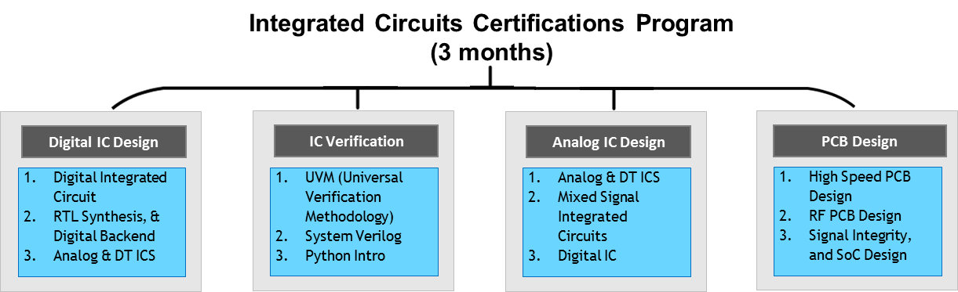

**Certification in Integrated Circuits Design:**

Courses for Certification in Integrated Circuits:

1. Digital Integrated Circuits
2. Analog & DT Integrated Circuits
3. Mixed Signal Integrated Circuits
4. Python Introduction
5. High-speed PCB Design
6. RF PCB Design
7. UVM (Universal Verification Methodology)
8. Signal Integrity, Packaging and SoC Design
9. RTL Design Synthesis

## Teaching Faculty:

Teaching faculty is hands on IC designer with cumulative experience of over dozen IC tape outs in different technologies.

For CVs of faculty, please see (<http://isb.nu.edu.pk/rfcs2/team.htm>)

* Prof. Dr. Rashad Ramzan
* Dr. Hassan Saif
* Dr. Shazad Saleem
* Dr. Arshad Hassan
* Engr. Hamza Atiq (MS EE)
* Engr. Ali Sabir (MS EE)

# Courses Curriculum

#### Compulsory Courses:

1. **Research Methodology:** The course is mandatory for all graduate programs offered under HEC umbrella. The course covers central aspects of the research process, as well as principles and questions related to state of art search, research planning, problem formulation, statistical data analysis, quality assessment, presentation of a research project, and research ethics. **(03 credits; HEC requirement)**
2. **Digital Integrated Circuits:** Review of IC fundamentals, CMOS Device Characteristics, Layout Rules, CMOS Inverter, Basic Gates, Combinational Logic Multiplexers, Transmission Gates, Sequential logic circuits, Latches, Flip Flops, Adders, Multiplier, Memory cells, Layout, Basic of Logic synthesis and use of CAD tools. **(03 credits)**

**Lab Tutorials:** Design of Basic Logic Gates, Flip Flop, Adders, Multiplexer, Demultiplexer, Memory Cells, Complex Circuits, and layout in cell library format in Cadence tool suite.

1. **Analog & DT Integrated Circuits:** Review of fundamentals, Analog building blocks, CMOS Device and Noise – Fundamentals, Single‐stage (CS, CG, CD), Differential pair and multistage amplifiers, CMOS operational amplifier, Noise in CMOS Circuits, Feedback Principles, Current Sources and Current Mirrors, MOS Switched‐ Capacitor (SC) circuits, OTA, and Gm cells. **(03 credits)**

**Lab Tutorials:** CMOS DC Analysis, Common Source Amplifier, Common Gate Amplifier, Multi Stage Amplifiers, Common Drain Amplifier, CMOS Current Mirrors, Differential Amplifiers, Two Stage Op-Amp, CMOS Noise Analysis, Advanced Layout Techniques in Cadence Tool Suite.

1. **Mixed‐Signal Integrated Circuits:** Non‐Linearity and mismatch, CMOS Processing Technology, Layout Fundamentals, Sample & Hold Circuits, Voltage Comparators, Band‐gap References, Data converters – Fundamentals and Performance Metrics, Nyquist Digital‐to‐Analog Converters, Nyquist Analog‐to‐Digital Converters, Z‐Transform, Oversampling ΣΔ Data Converters, PLL and Frequency Synthesizers. **(03 credits)**

**Lab Tutorials:** Advanced op-amp Design & Simulation, CMOS Comparators Design, Bootstrap Circuits Design, Switched Capacitor Circuits Design, Discrete circuit Layout Techniques, Nyquist Rate DAC Design, Nyquist Rate ADC Design, Sigma-Delta Converters, Oscillator & PLL circuits, Bandgap Reference Circuits in Cadence tool suite.

#### Elective Courses:

1. **Signal Integrity, Packaging and Chip Design:** Signal Integrity Principals, Chip interconnect and Transmission Lines, PCB and IC Materials, Impedance Matching, Power Distribution Network, Parallelism & Cross Talk. EMI and EMC, Reflections and Termination and IO Pads, On-Chip Passives, ESD Protection Management, IC and Discrete Component Packaging, Thermal Consideration, IC Failure and Reliability, Microsystems Packaging and Applications. **(03 credits)**

**Lab Tutorials:** Impedance Matching using Lumped Model, Impedance Matching using Microstrip Model, EMC and TL Discontinuity Modeling and Simulation, Bond wire Modeling and Simulations, Power Distribution Network Modeling, Parallelism Transmission Line Modeling & Analysis, Crosstalk and Noise Analysis, EMI/EMC Interference Analysis, On-Chip Passives and Corner Analysis

1. **RTL Synthesis, & Digital Backend:** Basics of HDL (Verilog) Coding. Synthesizable RTL, State Machine Design, HDL Testbench Design, RTL Code Compilation Scripts Development, Placement and Routing, Static Timing Analysis (STA), CLK Insertion, RISC-V for Embedded Systems. **(03 credits)**

**Lab Tutorials:** Introduction to Verilog and Modelsim, State Machine Design, RTL Synthesis using Standard Cell Libraries, Place, Route, and Static Timing Analysis, Physical Layout using Cadence Genus, Innovus etc. Fullchip Physical Verification (DRC/LVS).

1. **RF Integrated Circuits:** Basics Concepts of RF Electronics, Linearity (1dB CP and IIP3) and noise (Noise Figure) in radio circuits, High frequency model of the CMOS and BJT circuits, IC technology suitable for radio circuit design, Radio Standards, Radio Transceiver Architectures, Radio Transceiver Calculations, Transmission lines and impedance matching, Wideband and Narrow band design issues, Low Noise Amplifiers (LNAs), Active and Passive Mixers, Voltage Controlled Oscillators and Phase Lock Loops, Power Amplifiers. **(03 credits).**
2. **IC Design Project: From Schematic to Chip Tapeout:** Project selection, Pre‐study, and Floor planning, Schematic/HDL Capture, Architectural level, Gate/Transistor level, Synthesis and simulations, Pad Frame Selection and Design, Library Mapping and Optimization, Analog ad Digital Layout Strategies, DRC, Post‐Layout Verifications, Back Annotations, Generation of Mask data‐base for Chip‐Layout, Final Tapeout. **(03 credits)**

**Spring 2021 Taped out Projects**

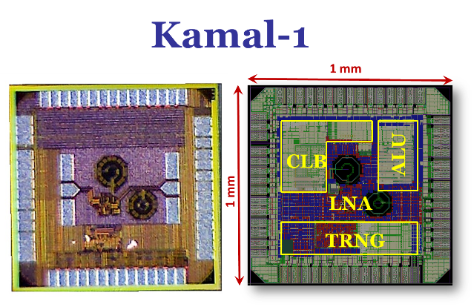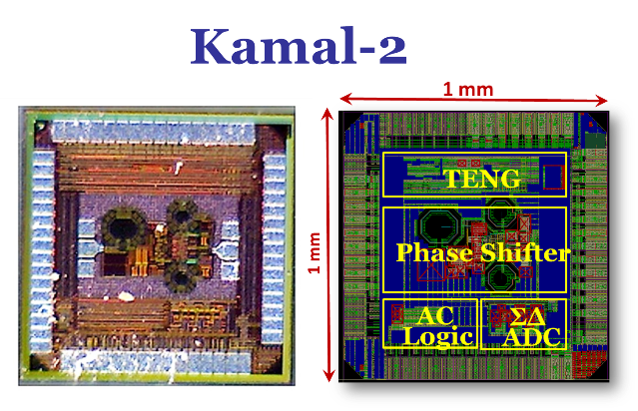

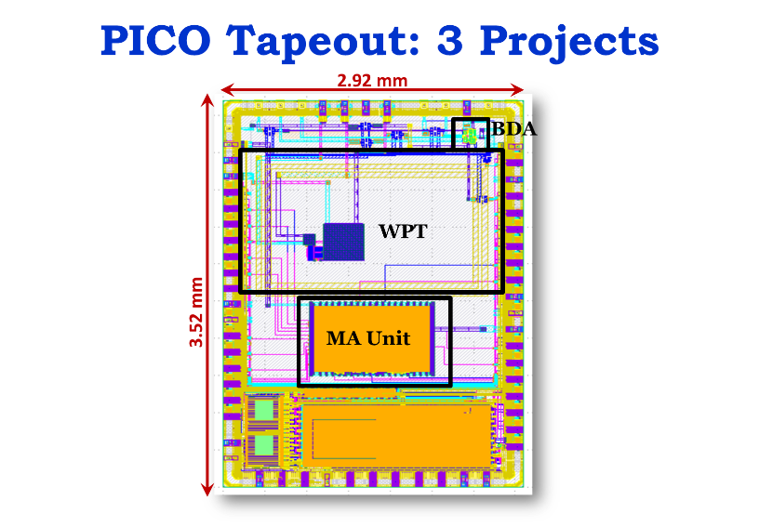

***This is hand-on IC design course, which needs intensive LAB work.***

1. **Printed and Flexible Electronics:** Flexible and Printed Electronics and their Materials Systems, Thin‐film Deposition and Processing Methods, Substrates for flexible electronic devices and circuits, Resistive switching devices (memristors) and their applications, OLEDs and their applications in thin‐film transistor‐based (OTFTs) displays, Flexible organic photovoltaics (OPVs), Thin‐Film Transistors, Flexible batteries, Interfaces to Organic and Inorganic Electronic Devices, Energy harvesting technologies, flexible electronic packaging. **(03 credits)**
2. **Advance Embedded Systems:** Basics of processor architectures. Memory organization and caches. Worst‐Case Execution Time (WCET) Analysis, Compositional Timing Analysis for embedded systems, Embedded software platforms, Performance analysis, memory hierarchy, buses, peripherals, Wireless Sensor Networks, Internet of Things, Embedded systems platforms: MCUs, DSPs, GPU, FPGAs, Code optimization, Factors affecting Execution time, Multi‐tasking and real‐time operating systems, Scheduling algorithms and their performance. **(03 credits)**

**Lab Tutorials/Class Project:** Design and implementation of simple RISC processor on FPGA.

1. **Advance Digital Signal Processing:** Introduction, Discrete‐time Fourier transform (DTFT), Sampling & reconstruction, Fast Fourier transform (FFT), Using z‐transform to represent linear time‐invariant (LTI) systems, Digital filter design fundamentals, IIR, FIR and CIC filter design and implementation, DSP algorithm implementation issues and optimization, Linear prediction and optimal linear filters, Power spectrum estimations. **(03 credits)**

**Lab Tutorials/Class Project:** Implementation of FIR, IIR or CIC comb filter on FPGA.

1. **IC Marketing and Business Management:** Trends in the IC business: Technology and manufacturing trends, Demand, applications and product trends. Market Appearances: The customers, overall Business cycles, The bull‐whip effect), IC industry, supply & value chain, Geo distribution of Technology and fabrication centers, The dis‐integration of the value chain, outsourcing trends, Managing the marketing function: The sources of product ideas, The role of standard and intellectual property, The strategic partnership, distributorship and matching supply with demand. (03 credits)
2. **Advanced Microwave Engineering:** Introduction to microwave engineering, microelectronics device and device models, Transmission lines theory, reflection and transmission analysis, Microwave network analysis, impedance matching networks and tuning, wideband impedance matching issues microwave resonators, Power Dividers and directional couplers, Microwave filters and their implementation, Noise in microwave circuits, Microwave amplifier design, Microwave oscillators and mixers circuits. **(03 credits)**
3. **High speed PCB Design:** Introduction to highspeed PCB Design: Substrate Materials & Fabrication, Packages & Connectors, Drivers/Receivers and IBIS models, Transmission Lines, Microstrips, Striplines & Differential Pairs, Coupling & Parallelism and Crosstalk, Impedance Control, Reflections, Terminations and Buses Design Preparation and Setting up Design Rules, Power and Noise Budgets, Plane stackup and Split Planes, Power Distribution and Grounding, EMI and EMC and Documentation. **(03 credits)**

**Lab Tutorials:** Introduction to PCB, schematic capture, routing and Signal Integrity tools, Symbols and Symbol Libraries, Parts, Layout and Design Rules, Floor Planning, Routing, and CAM files Generation, Signal Integrity Analysis and Case Studies of already designed

Qualified PCBs.

1. **RF PCB Design:** Introduction to RF PCB Design: Transmission Lines and S-Parameters,RF Filters, Bond Wires, RF Connectors, TDR Vs Frequency Dom. Measurements, Grounding and Current Return Path ADS Schematic and Layout Simulations, 2.5D Field Simulation using ADS Momentum. **(03 credits)**

**Lab Tutorials:** Simulation of basic strip lines and impedance control, effect of the substrate thickness, permittivity, and trace thickness on impedance, basic simulation models, cross-talk and coupled lines, automatic layout and optimization using ADS optimizer, The basic components and simulation of a RF Transceiver i.e. SAW Filters, LNA, Mixer, VCO, PLL, power amplifiers and their foot prints, Simulating all these aspects to consider while layout and simulation of these components, Case study of RF PCB layout, of 3D and 2.5D field simulation using ADS Momentum and full-wave 3D simulator Electromagnetic Design System(EMDS).

1. **UVM (Universal Verification Methodology):** Understand the UVM hierarchies and various components needed to build a comprehensive UVM Testbench, Design and implement various testbench components, such as driver, monitor, sequencer, agent, environment, scoreboard, coverage, and environment, and understand the configuration databases, factory override, Transaction Level Modeling (TLM), understand virtual sequences and virtual sequencers and Building a framework for UVM Testbench. **(03 credits)**
2. **System Verilog:** Writing System Verilog code to describe practical digital logic functions, intuitively and concisely, Rapidly debug your code, identify and fix syntax issues—whether common or obscure, employing System Verilog code enhancements and conveniences such as  ticked literals ('1) packed/unpacked arrays, imported packages, and user-defined type definitions (typedef), Utilize new syntaxes like typedef, struct, and enum to customize your code to application-specific  
   chip architectures or data-packet formats. Add assert statements to check key design properties, Develop reusable test bench code for simulating logic functions or bus operations, including defining a class of objects, calling its methods, constraining random stimuli, and using interface connections, Explain the key pillars of OOP. Identify the System Verilog keywords or constructs that support object encapsulation, inheritance, and polymorphism. State how they enable UVM verification methodology. **(03 credits).**
3. **Introduction to Python:** This course introduces core programming basics—including data types, control structures, algorithm development, and program design with functions—via the Python programming language. The course discusses the fundamental principles of Object-Oriented Programming, as well as in-depth data and information processing techniques. Students will solve problems, explore real-world software development challenges, and create practical and contemporary applications **(03 credits).**
4. **Advanced Wireless Communication:** Introduction to Wireless & Mobile Communications, Propagation Models, Channel Models, Channel Sounding, Equalization, Transmission & Multiple Access techniques: OFDM/OFDMA, SC‐FDMA etc., Multi-antenna Systems: MISO, SIMO, MIMO, diversity, beamforming, spatial multiplexing, space‐time coding (STC), BLAST architecture, massive MIMO, MIMO‐OFDM transceiver design, Current Wireless Standards: IEEE 802.11n/ac WiFi, 4G mobile: 3GPP LTE, 3GPP LTE‐ Advanced (Emphasis on radio access network (RAN) part), 5G RAN, Satellite Communications. **(03 credits)**

# Feedback from Industry:

**Aziz ur Rehman (General Manger NECOP):**

NECOP IC Design Fellows joined NIDC (NECOP) after completing their Master’s degree in EE with specialization in IC design from NUCES, FAST Islamabad. The fellows are serving in the fields of analog/mixed signals and digital IC design. They have a sound understanding of Integrated circuit design and relevant theory. During this period, they acquired hands-on experience on the industry standard IC design tools leading to the tape-out of chips (e.g. KAMAL-1, KAMAL-2). KAMAL-1 and KAMAL-2 includes Fault tolerant CLB, Approximate ALU, True random number generator, mm-Wave LNA, AC logics, sigma delta converters, tribo electric nano-generator and mm-Wave phase shifter projects respectively. The courses were specifically designed to provide the students with a strong knowledge of electronics and IC design skills.

Teacher’s assistance and Lab facilities were available for the students 24/7. The faculty was very cooperative, knowledgeable and they trained the students according to the requirements of industry. Their personal interest and hard work, especially Dr. Rashad Ramzan contributed to the grooming of the students and the success of the program. NECOP is satisfied with the quality and ability of graduates. They have the potential and ability to work as individuals as well as in a team.

**Dr. Nasir (Deputy DG NECOP):**

MS IC Design graduates from FAST-NU Islamabad campus are very professional and have good knowledge base in all domains (Digital, Analog, Mixed Signal and RF) of IC design. They have been trained using state of the art IC Design Tools. Having gone through the complete IC design and fabrication cycle during their MS through a tape out project using TSMC 65nm Technology has enhanced their confidence to take up real world IC Design projects. They are comfortably working with IC Design teams at NECOP giving valuable inputs. Their performance in the National IC Design Center at NECOP has enhanced our trust in home grown solutions for trained HR in the advanced field of IC Design. The level of their competence and confidence shows the quality of teaching and Lab work at NU FAST Islamabad campus in the field of IC Design.

# Feedback from Students:

**Hamza Saleem (Fellow MS IC Design):**

All the faculty members at FAST are dedicated, passionate and supporting, especially Prof. Rashad Ramzan. He’s more than a teacher for me. He changed the way of thinking, helped me develop my intuitions about design concepts. Besides, I remember the time when I asked a question to Dr. Hassan via WhatsApp message. He called me back and discuss the issue briefly. I did several meetings with faculty about Tape-out project and thesis and remember the positive criticism and highlighting the design issues from faculty. In a nutshell, I learnt several new concepts and developed design intuitions under the guidance of all faculty member. One thing I must say! After working with the faculty, if you put your whole effort too, you will be a practical Chip designer.

**M. Usman (Fellow MS IC Design):**

I have very unique experience while studying IC Design at FAST-NU. It was the only program of its kind in Pakistan, where I was able to learn IC design from scratch to tape out. The program offered me a variety of skills including; design, plan, management, economy, and art of designing practical circuits, that are much needed while designing real world chips. Definitely, it is a lot of work, but the experience worth it.

**Jaffar Hussain (Fellow MS IC Design):**

After bachelors I was looking for graduate program that can enhance my technical skills in practical domain. The Master program in IC Design at FAST provided me that opportunity. IC design is a field in which Pakistan need qualified human resource and this Master program at FAST is working towards it. This program is perfect for, Engineers seeking in-depth training from concept to tape-out in analog and digital IC design.

Our Group:

